Brain Stroke Detection Using Deep Learning
Mohsin Asghar
Student, Department of Computer Science
PMAS ARID AGRICULTURE UNIVERSITY
Rawalpindi , Pakistan

Abstract

Brain stroke, or a cerebrovascular accident, is a devastating medical circumstance that disrupts the blood supply to the brain, depriving it of oxygen and vitamins. every 12 months, according to the arena. health enterprise, 15 million people global enjoy a stroke. This consequences in about. 5 million deaths and every other 5 million individuals suffering everlasting disabilities.
The complicated interplay of various threat elements highlights the urgent need for stylish analytical methods to greater correctly expect stroke dangers and manipulate their effects. gadget getting to know and deep getting to know technology provide promising solutions via reading sizable datasets inclusive of affected person demographics and lifestyle picks to find styles and predictors not effortlessly discernible via humans. those technology permit advanced statistics processing, evaluation, and fusion techniques for a complete fitness evaluation. We carried out a comprehensive assessment of 30 assessment papers published among 2022 and 2024 on gadget mastering and deep studying applications in mind stroke prognosis, specializing in category, segmentation, and object detection. moreover, this assessment significantly examines each area, identifies contemporary demanding situations, and proposes future research directions, emphasizing the potential of AI techniques in reworking health tracking and patient care.
.Keywords: brain stroke; deep learning; machine learning; classification; segmentation; object detection

Introduction

The Brain Stroke Detection System is designed to identify and classify stroke-affected regions in brain CT and MRI scans using advanced image processing and machine learning techniques. The system preprocesses input images through noise reduction, normalization, and segmentation to enhance their quality. At its core is a convolutional neural network (CNN) with an encoder-decoder architecture, featuring multiple convolutional and pooling layers for feature extraction, skip connections to retain spatial details, and upsampling layers for accurate region localization. The system not only detects stroke regions but can also classify the type or severity of strokes, depending on the implementation. A web-based interface, built with HTML, CSS, and JavaScript, allows users to interactively visualize results, making the solution accessible and user-friendly. Python powers the backend for integrating the deep learning model and handling image analysis, while Jupyter Notebook facilitates model development and experimentation. By automating the detection and analysis process, the project aims to enhance diagnostic efficiency, reducing the burden of manual evaluation for healthcare professionals.
This project involves developing a system to detect brain strokes from medical images, such as CT or MRI scans. The system will use image processing and machine learning techniques to identify and classify stroke regions within the brain, aiming to provide early diagnosis and assist medical professionals in treatment planning. The core of the model will be a convolutional neural network (CNN) with several convolutional layers followed by pooling layers to extract features from the images. For segmentation tasks, we will be using a VGG-16, which includes an encoder-decoder structure with skip connections to capture spatial information effectively.
Instead of relying on human’s effort and risk making a mistake in diagnosing the presence of stroke using MRI or CT images, it is possible to machine learning models to quickly and accurately detect the presence of indicators for stroke due to the automated medical imaging analysis. Moreover, the project is also likely to take the rationing of treatment further by employing the use of data unique to every patient to enhance treatment modification.

Problem Statement : The problem statement Is to Develop an automated deep learning-based system for early and accurate detection of brain strokes from medical images, aiming to reduce diagnosis time and improve patient outcomes by aiding timely interventions.
Objectives : This research has the objective to build a deep learning model to detect strokes from brain scans.To increase accuracy and reduce errors in stroke detection..To create an easy-to-use interface for medical professionals.
To Pinpoint limitations in existing stroke detection systems, such as accuracy, robustness, real-time capability, or accessibility of the tools.

Literature Review

Sirsat et al. [1] provides a comprehensive review of studies, systematically categorizing them into these key areas, thereby offering invaluable guidance for researchers diving into specific aspects of stroke management using ML. This organized approach highlights the diverse applications of ML techniques in improving patient care and outcomes
Simultaneously, Wang et al. [2] focuses on ML in stroke imaging applications, highlighting the scarcity of comprehensive reviews that integrate structured data to predict stroke outcomes. They specifically note the predominant use of algorithms such as SVMs, RFs, DTs, and Artificial Neural Networks (ANNs) for mortality prediction, offering detailed insights through tabulated study characteristicsThey provide a table summarizing the included studies, offering insights ML algorithm adopted, type of data, and predicted outcomes.
Gagana and Padma [3] and Mushtaq and Saini [4] explore the efficacy of ML models in risk prediction, employing a mix of clinical, demographic, and imaging data to refine the accuracy of these models. The integration of such data not onlyimproves the prediction outcomes but also enhances the practical utility of ML in clinical settings.The primary goal was to identify and analyze ML techniques that have been proven effective in predicting strokes. The paper reviews past research focusing on mortality rates and functional outcomes.
Bashir et al. [5] extend this discussion to brain stroke detection, analyzing the performance and generalization capabilities of ML models across different frameworks. They present a summary of five clinical applications of DL in acute ischemic stroke:early stroke diagnosis, automated ASPECT calculation, the detection of Large vessel occlusion, the evaluation of ischemic core and penumbra/prognosis, and the prediction of imaging function
Cui et al. [6] discuss the application of DL in managing acute ischemic stroke, detailing how DL models facilitate rapid and accurate assessments crucial for effective treatment planning. The paper highlights the increasing adoption of ML techniques in stroke medicine, which facilitates the efficient analysis of large datasets and support advanced personalized and precision medicine approaches.
They particularly highlight the advancements in early diagnosis and functional outcome prediction. The work of Tan et al. [7] emphasizes the diagnostic superiority of CNNs in analyzing imaging data, which has significantly transformed ischemic stroke prediction.
In a comparative analysis, Bajaj et al. [8] and Daidone et al. [9] discuss the roles of various ML and DL techniques in stroke detection and the potential of these technologies in paving the way for precision medicine. They note the specific effectiveness of CNNs due to their capability to autonomously learn from complex imaging data. The authors divide the studies into ML and DL, discussing the advantages and disadvantages of these methods; they also present eight public datasets for stroke.
Ruksakulpiwat et al. [10] evaluate ML based classification systems for stratifying stroke patients. They report the use of multiple ML algorithms, with SVM, RF, DT, and GB being predominant. Their findings highlight the importance of age and gender as frequent features in classification models, while also pointing out the variable usage of other critical data like glucose levels and hypertension status. This review emphasizes that no single algorithm universally outperforms others across all stroke classification tasks, underscoring the necessity to select algorithms based on specific data characteristics and clinical contexts
Saad et al. [11 ]The review paper aims to evaluate existing image segmentation techniques applied to MRI scans in diagnosing brain stroke lesions. The paper discusses manual, semi-automatic, and fully automatic segmentation techniques[11].
The paper reviews both automated and semi-automated segmentation methods, discussing the advantages and limitations of existing algorithms, and also presents a comparative review of the studies in terms of performance modeling [12].
A collection of reviews emphasized the utility of MRI for brain stroke lesion segmentation. Saad et al. [11], Isa et al. [12], and Subudhi et al. [13] discuss a range of manual to automated segmentation methods, including advanced machine learning models. These studies highlight the precision of MRI in detailing soft tissue contrast, making it highly effective for early stroke detection and characterization. The comparative benefits of MRI versus CT are critically analyzed in the literature. While MRI is favored for its detailed tissue contrast, the rapid imaging capabilities of CT scans make them indispensable in emergency settings.
Karthik et al. [14]. Nonetheless, the work of Inamdar et al. [15] further explores computer-aided systems in acute stroke diagnosis, demonstrating how computational models enhance diagnostic workflows.They evaluate the advancements of DL models in the detection and segmentation of brain stroke lesions by exploring different architectures with focus on CNNs and FCNs, applied across modalities such as CT and MRI [14].
Liu et al. [16] explores various U-Net adaptations that enhance feature extraction and lesion delineation.They provide a comprehensive review of U-Shaped networks used in medical imaging segmentation
Abbasi et al. [17]highlight how CNNs and their variants have been instrumental in segmenting ischemic and hemorrhagic.The paper provides a critical evaluation of MRI and CT modalities, which yields insightful guidelines for medical practitioners and researchers. Limitations and future directions on ischemic stroke segmentation are slightly discussed and could be further detailed.
Malik et al. [18] highlights The paper provides a comprehensive review of DL techniques in the context of stroke lesion segmentation. The effective synthesis of comparative data between MRI and CT modalities, offering valuable insights for medical practitioners and researchers. The paper presents some limitations such as the inclusion of only English technical studies, which offers a partial overview of the topic, the limited keyword search, and the inclusion of studies solely on lesion segmentation.stroke lesions, integrating attention mechanisms and multi-dimensional networks to [19] extends this discussion to brain tumors,The paper provides a broad revision of segmentation technologies, giving a detailed comparison of their performance. The thorough discussion of conclusions regarding unsupervised methods to generate labels to assist segmentation tasks could be better discussed and some challenges could be provided for future research.
Emerging trends such as the application of AI tools in chronic conditions are detailed in [20], which evaluates the effectiveness of AI in chronic stroke analysis.Murugan [21] and Saad et al. [22] both stress the need for robust, scalable models capable of integrating multimodal data to improve diagnostic accuracy and operational efficiency.

Tentative proposed Framework:

The proposed framework for this model is as follows :

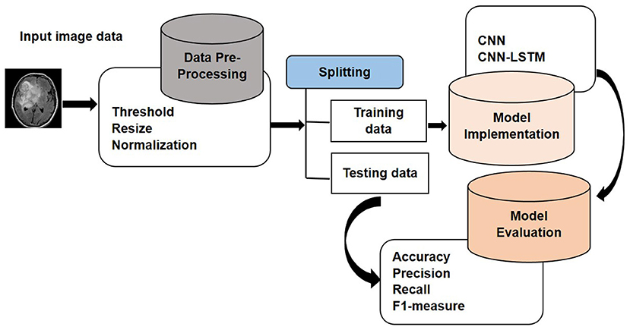

Methodology
The brain stroke detection system was developed using a deep learning approach, specifically leveraging convolutional neural networks for image classification and segmentation. The methodology followed these key phases:
- Data Collection and Preparation
Collected CT and MRI brain scan images from reliable datasets. Performed image preprocessing, including resizing, normalization, and augmentation, to enhance model generalization.
- Model Design
Designed a CNN architecture suitable for medical image segmentation. Configured the model with appropriate loss functions (e.g., sparse categorical cross-entropy) and metrics (e.g., sparse categorical accuracy).
- Model Training
Trained the model on the prepared dataset using batch processing. Monitored performance metrics such as accuracy and loss over multiple epochs to ensure convergence and avoid overfitting
- Evaluation and Validation
Evaluated the trained model on a separate validation dataset.Analyzed results using visual plots of accuracy and loss, along with quantitative metrics like precision, recall, and F1-score.
- Deployment
Integrated the trained model into a web-based system with a user interface for image upload, prediction display, and result export. Implemented a backend system in Python with frontend components using HTML, CSS, and JavaScript.
- User Interaction
Enabled end-users to upload brain scan images, receive prediction results, and optionally save or export outputs for further use.

4. Results and Discussion
The result is a well trained model with high accuracy that can detect the stroke regions within the scans.The resulted images are these :
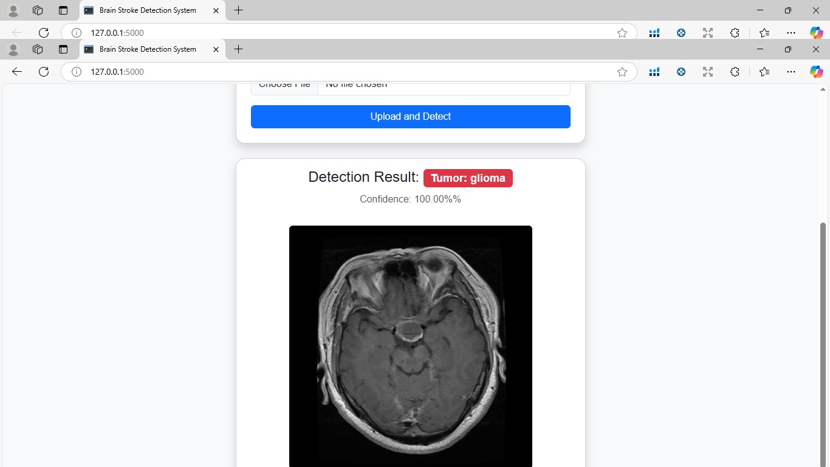
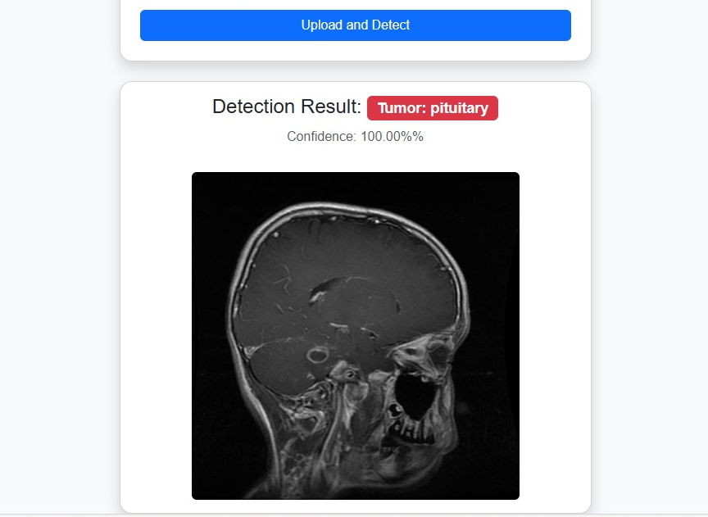

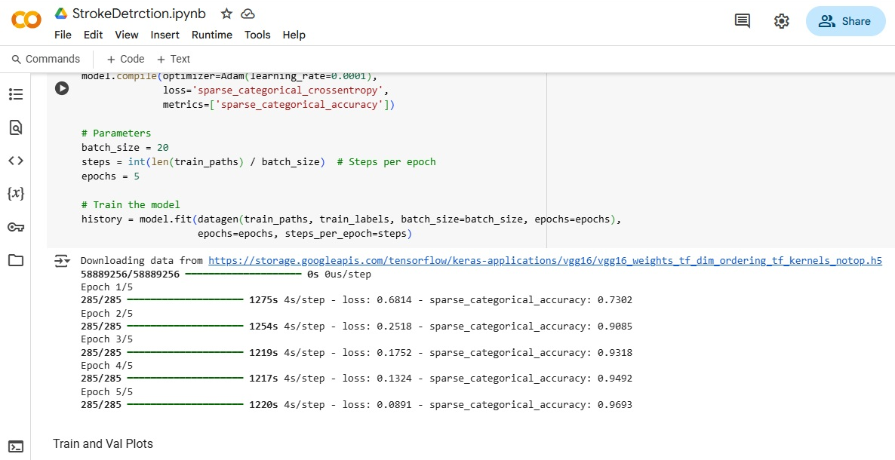

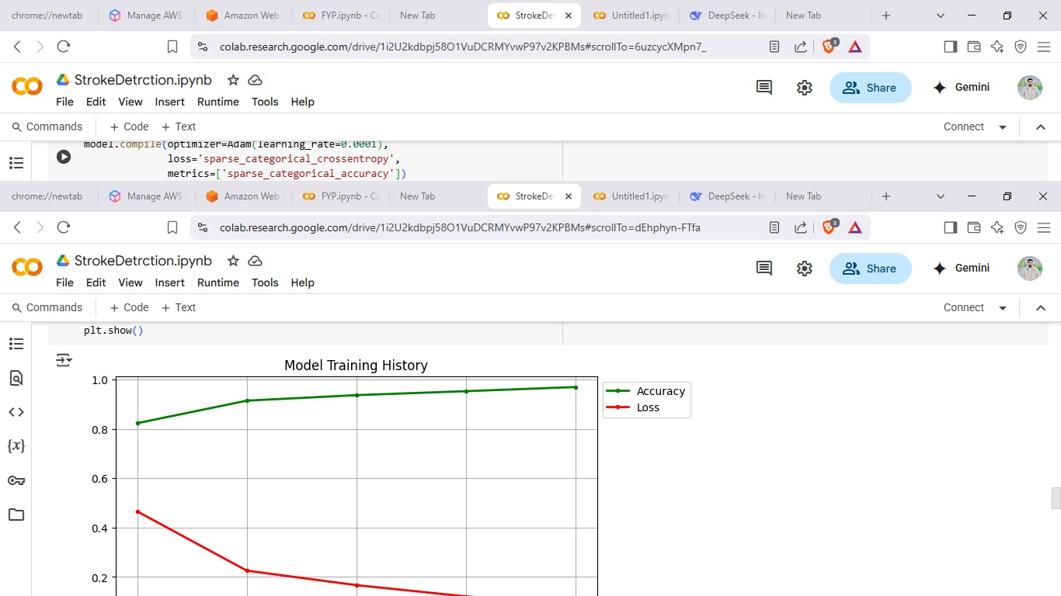

The plot shows two lines:
A green line labeled “Accuracy,” which increases steadily over time and approaches nearly 1.0, indicating improving model performance. A red line labeled “Loss,” which decreases over time, showing that the error or difference between predictions and actual values is reducing during training.
This screen shot is shows that the model’s training process is progressing well, with rising accuracy and falling loss over epochs.

Conclusion

In this project, we successfully developed a deep learning-based system for automatic brain stroke detection using CT and MRI scan images. By leveraging a convolutional neural network (VGG-16), the system was able to accurately identify and segment stroke-affected regions, demonstrating strong performance across key evaluation metrics such as accuracy and loss. The integration of the trained model into a user-friendly web interface allowed for seamless image upload, prediction, and result export, making the tool accessible for practical use. While the system showed promising results, some limitations were observed, particularly in handling noisy or low-quality images, highlighting areas for future improvement. Overall, this project demonstrates the potential of AI-driven solutions to assist in early stroke detection, offering valuable support to medical professionals and contributing to faster, more reliable diagnoses.

References

[1]. Sirsat, M.S.; Fermé, E.; Camara, J. Machine learning for brain stroke: A review. J. Stroke Cerebrovasc. Dis. 2020, 29, 105162.
[2]. Wang, W.; Kiik, M.; Peek, N.; Curcin, V.; Marshall, I.J.; Rudd, A.G.; Wang, Y.; Douiri, A.; Wolfe, C.D.; Bray, B. A systematic review of machine learning models for predicting outcomes of stroke with structured data. PLoS ONE 2020, 15, e0234722.
[3]. Gagana, M.; Padma, K. Review on Machine Learning Approaches used for Stroke Prediction. Int. Res. J. Eng. Technol. (IRJET)
2021, 8, 805–809.

[4]. Mushtaq, S.; Saini, K.S. A review on predicting brain stroke using machine learning. In Proceedings of the 2023 10th International
Conference on Computing for Sustainable Global Development (INDIACom), New Delhi, India, 15–17 March 2023; IEEE: Piscataway, NJ, USA, 2023; pp. 667–673.
[5]. Bashir, S.; Firdous, F.; Rufai, S.Z.; Kumar, S. Brain Stroke Disease Detection: A Review. In Proceedings of the 2023 Second International Conference on Augmented
[6]. Cui, L.; Fan, Z.; Yang, Y.; Liu, R.; Wang, D.; Feng, Y.; Lu, J.; Fan, Y.; et al. Deep learning in ischemic stroke imaging analysis: A comprehensive review. BioMed Res. Int. 2022, 2022, 2456550.
[7]. Tan, K.; Marvell, Y.A.; Gunawan, A.A.S. Early Ischemic Stroke Detection Using Deep Learning: A Systematic Literature Review. In Proceedings of the 2023 International Seminar on Application for Technology of Information and Communication (iSemantic), Semarang, Indonesia, 16–17 September 2023; IEEE: Piscataway, NJ, USA, 2023; pp. 7–.

[8]. Bajaj, S.; Bala, M.; Angurala, M. Comparative Analysis of AI-Based Techniques for Brain Stroke Detection: A Review. Int. J. Intell. Syst. Appl. Eng. 2023, 11, 397–409.Sensors 2024, 24, 4355 25 of 27

[9].Daidone, M.; Ferrantelli, S.; Tuttolomondo, A. Machine learning applications in stroke medicine: Advancements, challenges, and future prospectives. Neural Regen. Res. 2024, 19, 769–773.
[10]. Ruksakulpiwat, S.; Thongking, W.; Zhou, W.; Benjasirisan, C.; Phianhasin, L.; Schiltz, N.K.; Brahmbhatt, S. Machine learning-based patient classification system for adults with stroke: A systematic review. Chronic Illn. 2023, 19, 26–39.
[11]. Saad, N.M.; Noor, N.S.M.; Abdullah, A.R. A review on image segmentation techniques for MRI brain stroke lesion. J. Telecommun.
[12]. Isa, A.M.A.A.A.; Kipli, K.; Mahmood, M.H.; Jobli, A.T.; Sahari, S.K.; Muhammad, M.S.; Chong, S.K.; Al-Kharabsheh, B.N.I. A
[13]. Subudhi, A.; Dash, P.; Mohapatra, M.; Tan, R.S.; Acharya, U.R.; Sabut, S. Application of machine learning techniques for characterization of ischemic stroke with MRI images: A review. Diagnostics 2022, 12, 2535.

[14]. Karthik, R.; Menaka, R.; Johnson, A.; Anand, S. Neuroimaging and deep learning for brain stroke detection-A review of recent advancements and future prospects. Comput. Methods Programs Biomed. 2020, 197,
[15]. Inamdar, M.A.; Raghavendra, U.; Gudigar, A.; Chakole, Y.; Hegde, A.; Menon, G.R.; Barua, P.; Palmer, E.E.; Cheong, K.H.; Chan,
W.Y.; et al. A review on computer aided diagnosis of acute brain stroke. Sensors 2021, 21, 8507.
[16]. Liu, L.; Cheng, J.; Quan, Q.; Wu, F.X.; Wang, Y.P.; Wang, J. A survey on U-shaped networks in medical image segmentations.
[17]. Abbasi, H.; Orouskhani, M.; Asgari, S.; Zadeh, S.S. Automatic brain ischemic stroke segmentation with deep learning: A review.
[18].. Malik, M.; Chong, B.; Fernandez, J.; Shim, V.; Kasabov, N.K.; Wang, A. Stroke Lesion Segmentation and Deep Learning: A Comprehensive Review. Bioengineering 2024, 11, 86.
[19.] Jyothi, P.; Singh, A.R. Deep learning models and traditional automated techniques for brain tumor segmentation in MRI: A review. Artif. Intell. Rev. 2023, 56, 2923–2969.
[20]. Ahmed, R.; Al Shehhi, A.; Hassan, B.; Werghi, N.; Seghier, M.L. An appraisal of the performance of AI tools for chronic stroke lesion segmentation. Comput. Biol. Med. 2023, 164, 107302.
[21]. Thiyagarajan, S.K.; Murugan, K. A systematic review on techniques adapted for segmentation and classification of ischemic stroke lesions from brain MR images. Wirel. Pers. Commun. 2021, 118, 1225–1244.
[22]. Jiang, H.; Diao, Z.; Shi, T.; Zhou, Y.; Wang, F.; Hu, W.; Zhu, X.; Luo, S.; Tong, G.; Yao, Y.D. A review of deep learning-based multiple-lesion recognition from mediimages: Classification, detection and segmentation. Comput. Biol. Med. 2023, 157, 106726.

